
IW-14
YEAR 7 SCIENCE
CHEMICAL SCIENCES (MODIFIED)
TEST

NAME: CLASS: Mark: 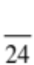

Achievement standards being tested
Mixtures, including solutions, contain a combination of pure substances that can be separated using a range of techniques.

Mark | ND | NW | C | HC | O
Mark Range | 0-4 | 5-8 | 9-13 | 14-17 | 18-24

Multiple Choice Write the answer to each question in the appropriate box at right.

1. Water is a solvent for alcohol. This means that alcohol:
QUESTION | ANSWER
1
2
3
4
5
6
7
8
9

A will not dissolve in water.
B will dissolve in water.
C will react chemically with water.
D will dissolve only in water.

2. Which mixture could be separated using a magnet?

A Nails and paperclips.
B Iron filings and sulphur.
C Iron filings and paperclips.
D Sand and sulphur.

3. A solid which dissolves in another substance is called a:

A solvent.
B solution.
C solute.
D sediment.

4. Which one of the following is incorrect? An insoluble substance may:

A form a solution.
B form a suspension.
C form a sediment.
D float on top of a liquid.

5. Suppose you were given a white powder and told to stir it into a beaker of water. You would know that the powder had dissolved in the water if:

A the powder settled to the bottom of the beaker and left the water clear.
B the powder floated on top of the water and did not mix.
C the powder disappeared and left the water clear.
D the powder disappeared and made the water cloudy.
6.
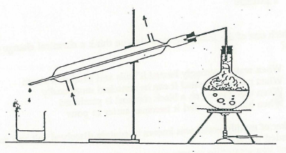

The process shown in the diagram above is called:

A evaporation.
B solidification.
C distillation.
D decantation.

7. Inks can be separated into their coloured components by:

A filtration.
B chromatography.
C crystallisation.
D distillation.

8.
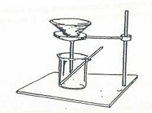
The apparatus shown above could be used to separate:

A sand from water.
B salt from sugar.
C salt from water.
D iron from iron sulphide.

9. What is the best way to obtain sugar from a sugar solution?

A Condensation.
B Evaporation.
C Sieving.
D Filtration.

Short Answer Write the answer to the questions in the spaces provided.

1. Choose the correct definition for the term in the first column of the table below. Write the correct letter in the second column.

TERM | CORRECT LETTER | DEFINITION
solvent |  | A: substances that cannot dissolve.
saturated solution |  | B: the solid that settles on the bottom of a  container of water.
sediment |  | C: pouring water off the top, leaving a solid behind.
sieving |  | D: no more solid is able to dissolve in a liquid.
insoluble |  | E: small particles that float in a liquid, making it  cloudy.
suspension |  | F: the substance that dissolves a solid.
decanting |  | G: small particles pass through and large ones  remain behind.

(7)

2. To make a chocolate milkshake more concentrated, should you add more milk or more flavouring?

(1)

3. A squeeze of lemon juice is mixed with a glass of cold water to make a home-made
lemon drink. Put the underlined words into the correct spaces below.

(a) solute

(b) solvent

(c) solution (3)

4. Tom has a mixture of small pebbles and some iron nails. He has to separate them and realises that iron has a special property that he can use.

(a) Which of the following methods of separating substances would he use?

• decanting • sieving
• magnetic • evaporating
• filtering • distillation

(1)

(b) Why would he use this method?

(1)

(c) Mary has a solution of blue copper sulphate in a beaker. She wants to have the copper sulphate by itself in the beaker.

(i) Which of the above separation methods would she use?

(1)

(ii) Explain how this method works.

(1)

